**What is a Multiplexer and De-multiplexer?**

# Multiplexer

Multiplexer is a device that has multiple inputs and a single line output. The select lines determine which input is connected to the output, and also to increase the amount of data that can be sent over a network within certain time. It is also called a data selector.

[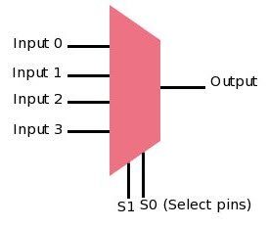](https://www.elprocus.com/wp-content/uploads/2014/04/27.jpg)Multiplexer

The single pole multi-position switch is a simple example of non-electronic circuit of multiplexer, and it is widely used in many [electronic circuits](https://www.elprocus.com/step-step-guide-build-electronic-circuit/). The multiplexer is used to perform high-speed switching and is constructed by [electronic components](https://www.elprocus.com/basic-components-used-electronics-electrical/).

Multiplexers are capable of handling both analog and [digital applications](http://www.edgefxkits.com/home-automation-using-digital-control). In analog applications, multiplexers are made up of of relays and transistor switches, whereas in digital applications, the multiplexers are built from standard logic gates. When the multiplexer is used for digital applications, it is called a digital multiplexer.

**Multiplexer Types**

Multiplexers are classified into four types:

* 2-1 multiplexer ( 1select line)
* 4-1 multiplexer (2 select lines)
* 8-1 multiplexer(3 select lines)
* 16-1 multiplexer (4 select lines)

**8-to-1 Multiplexer**

[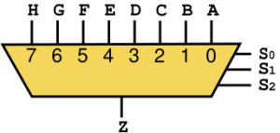](https://www.elprocus.com/wp-content/uploads/2014/04/35.jpg)8-to-1 Multiplexer

The 8-to-1 multiplexer consists of 8 input lines, one output line and 3 selection lines.

**8-1 Multiplexer Circuit**

For the combination of selection input, the data line is connected to the output line. The circuit shown below is an 8*1 multiplexer. The 8-to-1 multiplexer requires 8 AND gates, one OR gate and 3 selection lines. As an input, the combination of selection inputs are giving to the AND gate with the corresponding input data lines.

In a similar fashion, all the AND gates are given connection. In this 8*1 multiplexer, for any selection line input, one AND gate gives a value of 1 and the remaining all AND gates give 0. And, finally, by using OR gate, all the AND gates are added; and, this will be equal to the selected value.

[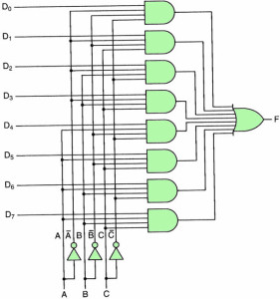](https://www.elprocus.com/wp-content/uploads/2014/04/43.jpg)8-1 Multiplexer Circuit

**Applications of Multiplexers**

Multiplexers are used in various applications wherein multiple-data need to be transmitted by using single line.

* **Communication System**

A [communication system](https://www.elprocus.com/basic-elements-of-fiber-optic-communication-system-and-its-working/) has both a communication network and a transmission system. By using a multiplexer, the [efficiency of the communication system](http://www.edgefxkits.com/vehicle-theft-location-intimation-by-gps-gsm-to-the-owner) can be increased by allowing the transmission of data, such as audio and video data from different channels through single lines or cables.

* **Computer Memory**

Multiplexers are used in computer memory to maintain a huge amount of memory in the computers, and also to reduce the number of copper lines required to connect the memory to other parts of the computer.

* **Telephone Network**

In telephone networks, multiple audio signals are integrated on a single line of transmission with the help of a multiplexer.

* **Transmission from the Computer System of a Satellite**

Multiplexer is used to transmit the data signals from the computer system of a spacecraft or a satellite to the ground system by [using a GSM satellite](http://www.edgefxkits.com/vehicle-tracking-by-gps-gsm).

# De-multiplexer

De-multiplexer is also a device with one input and multiple output lines. It is used to send a signal to one of the many devices. The main difference between a multiplexer and a de-multiplexer is that a multiplexer takes two or more signals and encodes them on a wire, whereas a de-multiplexer does reverse to what the multiplexer does.

[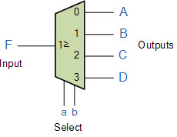](https://www.elprocus.com/wp-content/uploads/2014/04/52.jpg)De-multiplexer

**Types of De multiplexer**

De-multiplexers are classified into four types

* 1-2 demultiplexer  (1 select line)
* 1-4 demultiplexer  (2 select lines)
* 1-8 demultiplexer  (3 select lines)
* 1-16 demultiplexer (4 select lines)

**1-8 De-multiplexers**

The demultiplexer is also called as data distributors as it requires one input, 3 selected lines and 8 outputs. De-multiplexer takes one single input data line, and then switches it to any one of the output line. 1-to-8 demultiplexer circuit diagram is shown below; it uses 8 AND gates for achieving the operation. The input bit is considered as data D and it is transmitted to the output lines. This depends on the control input value of the AB. When AB = 01, the upper second gate F1 is enabled, while the remaining AND gates are disabled, and the data bit is transmitted to the output giving F1= data. If D is low, the F1 is low, and if D is high, the F1 is high. So the value of the F1 depends on the value of D, and the remaining outputs are in low state.

[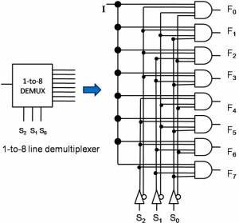](https://www.elprocus.com/wp-content/uploads/2014/04/63.jpg)1-8 De-multiplexer circuit

**Applications of De multiplexer**

De multiplexers are used to connect a single source to multiple destinations. These applications include the following:

* **Communication System**

Mux and demux both are used in [communication system](https://www.elprocus.com/introduction-to-types-of-microwave-antennas-in-communication-systems/) to carry out the process of data transmission. A De-multiplexer receives the output signals from the multiplexer and at the receiver end it converts them back to the original form.

* **Arithmetic Logic Unit**

The output of the ALU is fed as an input to the De-multiplexer, and the output of the demultiplexer is connected to a multiple register. The output of the ALU can be stored in multiple registers.

* **Serial to Parallel Converter**

This converter is used to reconstruct parallel data. In this technique, serial data is given as an input to the De-multiplexer at a regular interval, and a counter is attached to the demultiplexer at the control input to detect the data signal at the output of the demultiplexer. When all data signals are stored, the output of the demux can be read out in parallel.

This is the basic information about multiplexer and demultiplexers. Hope you might have got some fundamental concepts about this topic by observing the logic circuits and their applications. You can write your views about this topic in the comment section below.